

Date: July 2025

Syllabus - Teaching Program for the Course

**Intro to Biology - Lab**

**Elisheva Abberbock|** **Life Sciences**80-057-01

80-058-01

|  |  |
| --- | --- |
| **Course Type:** | Wet laboratory |
| **Scope of credits:** | 1 |
| **Year of study:** | 2025-26 |
| **Semester:** | Fall & Spring |
| **Day & Time:** | Thursday, 12:00 |
| **Reception Time:** | Monday and Wednesday at 10:00 |
| **Lecturer Email:** | Elisheva.abberbock@biu.ac.il |
|  |  |

**Course description and learning goals**

**Course Abstract**

This course will be a Hands-on, intro to biology laboratory, where students will be exposed to a wide array of techniques. This lab will help students understand how biological experiments are really done in a science lab. This is meant to be a crucial supplement to the biology course where they will cover much oral material, but here, students will get to work on the bench to see how science is performed. The end of the course will include tours of multiple labs in Bar Ilan to understand how the techniques practiced in the course are used in research labs and to hear about the latest research. Students will also get a tour of the core facilities in the Bar Ilan life sciences department to be able to see the latest technologies in action.

**Learning objectives**

Students will learn to work with basic laboratory equipment and techniques, including pipettes, microscopes, bacteria, dissections, and PCR. The students will gain understanding of what makes up living organisms and how we can break down these organisms into their building blocks. Students will learn to follow a protocol and work with a scientific process. Students will get to hear and see about cutting edge research being done at Bar Ilan University.

**Skills**

1. Students will gain familiarity and confidence using basic lab tools such as pipettes, scales, and microscopes.
2. Students will become familiar with basic lab techniques such as PCR, gel electrophoresis, dissections and bacterial culture.
3. Students will perform tasks independently, following a protocol using a variety of wet lab material
4. Students will evaluate experiments and draw scientific conclusions.

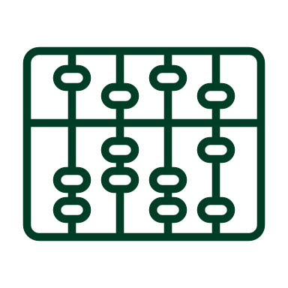**Active learning –** **lessons plan:**

|  |  |  |  |  |
| --- | --- | --- | --- | --- |
| Lesson No. | Topic | Active learning | Required reading | Assessment |
| 1 | Importance of scientific communication |  |  |  |
| 2 | Introduction to scientific instruments |  |  |  |
| 3 | Cell structure and function |  |  |  |
| 4 | Macromolecules: lipids and carbohydrates |  |  |  |
| 5 | Macromolecules: Nucleic acids |  |  |  |
| 6 | Macromolecules: Amino acids |  |  |  |
| 7 | Bacteria |  |  |  |
| 8 | PCR |  |  |  |
| 9 | Gel electrophoresis |  |  |  |
| 10 | Restriction enzymes and plasmids |  |  |  |
| 11 | Dissection |  |  |  |
| 12 | Western blots |  |  |  |
| 13 | Tour of TA’s Labs |  |  |  |
| 14 | Tour of Bar Ilan’s Core Facility |  |  |  |

(In a course that lasts a whole year, the additional sessions should be added)

* There may be changes in the syllabus depending on learning progress and effectiveness

**Final grade**

|  |  |
| --- | --- |
| Description of the learning product | Weight in the final score |
| Round robin style practical exam | 20% of final grade |
| Weekly quizzes | 10% of final grade |
| Final | 60% of final grade |
| TA evaluation of work and participation | 10% of final grade |

**Course** requirements

Students must attend all classes. More than one unexcused absence will result in deduction from final grade

Students must take all exams.

 **Prerequisites**

No prerequisites for this course