

Date: July 2025

Syllabus - Teaching Program for the Course

**CALCULUS 1**

**Prof. Malka Schaps|** **Mathematics**88731-01| Calculus 1

|  |  |
| --- | --- |
| **Course Type:** | Class |
| **Scope of credits:** | 3 |
| **Year of study:** | 2025-26 |
| **Semester:** | Fall |
| **Day & Time:** | Tuesday, 14:00-17:00 |
| **Reception Time:** | Tuesday. 13:30-14:00, Building 216, Room 122 |
| **Lecturer Email:** | [mschaps@math.biu.ac.il](mailto:mschaps@math.biu.ac.il) |
| **Moodle Site:** | ___ |

**Course description and learning goals**

**Course Abstract**

Calculus is a central tool in all fields of science and technology, including Computer __

_Science and Statistics. As such it is needed in the Social Sciences as well, including Medicine, Ecomomics and Business Administration.

**Learning objectives**

**Knowledge**

Differential Calculus, the topic of the first semester, is concerned with rates of change. When we say that a car travels 60 miles and hour, we are describing the rate of change of its distance from the starting point._.The student should come to know the importance of measuring rates of change and become familiar with applications.

**Skills**

The student will draw graphs of significant functions and calculate the slope of the graphs where the slope is defined. These slopes will be calculated as functions and evaluated at points. They will analyze the graphs of functions and optimize them, that is, calculate the maximum and minimum values.

**Values (if applicable)**

The students will practice writing the truth even when hurrying.

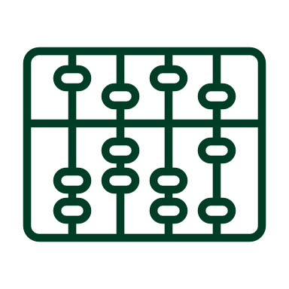**Active learning –** **lessons plan:**

|  |  |  |  |  |
| --- | --- | --- | --- | --- |
| Lesson No. | Topic | Active learning | Required reading | Assessment |
| 1 | Polynomials and their ratios |  |  |  |
| 2 | Inverting a function | Exercise |  |  |
| 3 | Domain of definition | Exercise |  |  |
| 4 | Absolute value |  |  |  |
| 5 | Limits of simple function | Exercise |  |  |
| 6 | Continuity |  |  |  |
| 7 | Graphs and their slopes | Exercise |  |  |
| 8 | Derivatives of simple functions |  |  |  |
| 9 | Derivatives of compositions | Exercise |  |  |
| 10 | L’Hospital’s rule for limits |  |  |  |
| 11 | Maximum and minimum points | Exercise |  |  |
| 12 | Optimizations problems |  |  |  |
| 13 | Exploring functions and graphs | Exercise |  |  |
| 14 |  |  |  |  |

(In a course that lasts a whole year, the additional sessions should be added)

* There may be changes in the syllabus depending on learning progress and effectiveness

**Final grade**

|  |  |
| --- | --- |
| Description of the learning product | Weight in the final score |
| Homework assignment | 20% of the final grade-minimum 60 |
| Final exam | 80% of final grade |

**Course** requirements

_Mathematics requires practice, so the Assignments are part of the grade_

Calculus is cumulative, so material from missed classes should be made up._________

 **Prerequisites**

Basic knowledge of high school algebra.

|  |  |
| --- | --- |
| Course number | Course name |
|  |  |



**Bibliography: Up-to-date** **reading, viewing, and listening content items**

* The textbook Calculus by George B. Thomas is recommended but not required.