

Date: July 2025

Syllabus - Teaching Program for the Course

**CALCULUS 2**

**Prof. Malka Schaps|** **Mathematics**88732-01| Calculus 2

|  |  |
| --- | --- |
| **Course Type:** | Class |
| **Scope of credits:** | 3 |
| **Year of study:** | 2025-26 |
| **Semester:** | Spring |
| **Day & Time:** | Tuesday, 14:00-17:00 |
| **Reception Time:** | Tuesday. 13:30-14:00, Building 216, Room 122. |
| **Lecturer Email:** | [mschaps@math.biu.ac.il](mailto:mschaps@math.biu.ac.il) |
| **Moodle Site:** | ___ |

**Course description and learning goals**

**Course Abstract**

_Calculus is a central tool in all fields of science and technology, including Computer __

_Science and Statistics. As such it is needed in the Social Sciences as well, including Medicine, Economics and Business Administration.

**Learning objectives**

**Knowledge**

Integral Calculus, the topic of the second semester, is concerned with calculation of areas by chopping them up into narrow strips or volumes which can be approximated by stacking disks. The students should become familiar with applications.

**Skills**

The student will analyze regions bounded by two functions and calculate the resulting area using integrals. Similarly, the student will calculate volumes of a solid of rotation using and integral.

**Values (if applicable)**

The students will practice writing the truth even when Trigonometric in a rush.

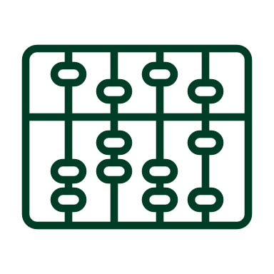**Active learning –** **lessons plan:**

|  |  |  |  |  |
| --- | --- | --- | --- | --- |
| Lesson No. | Topic | Active learning | Required reading | Assessment |
| 1 | Trigonometric functions |  |  |  |
| 2 | derivatives |  |  |  |
| 3 | Exponential functions and derivatives |  |  |  |
| 4 | Differentials |  |  |  |
| 5 | Antiderivatives and indefinite integrals |  |  |  |
| 6 | Integration methods: Substitution |  |  |  |
| 7 | Integrations by parts |  |  |  |
| 8 | Integration of rational functions |  |  |  |
| 9 | Methos of partial fractions |  |  |  |
| 10 | Trigonometric substitutions |  |  |  |
| 11 | Definite integral and area |  |  |  |
| 12 | Volume |  |  |  |
| 13 | Improper integrals |  |  |  |
| 14 |  |  |  |  |

(In a course that lasts a whole year, the additional sessions should be added)

* There may be changes in the syllabus depending on learning progress and effectiveness

**Final grade**

|  |  |
| --- | --- |
| Description of the learning product | Weight in the final score |
| Homework assignment | 20% of the final grade-minimum 60 |
| Final exam | 80% of final grade |

**Course** requirements

_Mathematics requires practice, so the Assignments are part of the grade_

Calculus is cumulative, so material from missed classes should be made up._________

 **Prerequisites**

Basic knowledge of high school algebra.

|  |  |
| --- | --- |
| Course number | Course name |
|  |  |



**Bibliography: Up-to-date** **reading, viewing, and listening content items**

The textbook Calculus by George B. Thomas is recommended but not required**.**