

Date: Sep. 2025

Syllabus - Teaching Program for the Course

**Hebrew -Ulpan level 1**

**Tsila Allon**06025| Elementary Hebrew Language Ulpan level 1

|  |  |
| --- | --- |
| **Course Type:** | class, exercise |
| **Scope of credits:** | 2 |
| **Year of study:** | 2025-26 |
| **Semester:** | Fall |
| **Day & Time:** | Tuesday at 12- 1:30pm |
| **Reception Time:** | Tuesday at 2pm |
| **Lecturer Email:** | cila.allon@biu.ac.il |
| **Moodle Site:** | ___ |

**Course description and learning goals.**

**Course Abstract**

In this course we will continue to acquire the basic vocabulary and structures of the Hebrew language with focus on speech, reading comprehension, and simple writing.

**Learning objectives**

This course takes the students from the mechanics of reading and writing Hebrew to active mastery Gradual Vocabulary; knowledge of the present tense verb forms and basic sentence structures; reading and enactment of dialogs relating to everyday life; and reading comprehension of short descriptive, narrative, and informative texts.

**Knowledge**

Familiarity of the basics on the written and spoken Hebrew:

* Familiarity of the basics on the written and spoken Hebrew.
* Day to day dialogs – speaking and reading.
* Understanding the basic syntax.
* Establishing a basic vocabulary.

**Skills**

By the end of the semester, it is expected that students will be able to:

* Read familiar text without vowels.
* Understand and produce an account of daily activities using the present tense, time of day and days of the week.
* Describe people, places, and actions both orally and in writing using newly acquired vocabulary and structures.
* Use numbers (to count, tell time and phone numbers, street address, etc.)
* Ask and answer simple questions (where, when, who, why, how, how much)

**Teaching techniques, technology use**

* During the lessons the students will talk, read texts, and write. PowerPoint presentations and digital practice will also be used.

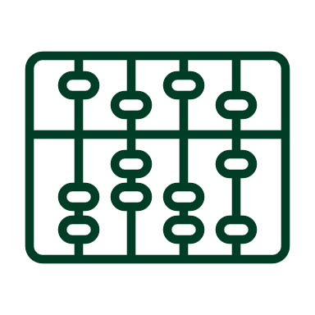**Active learning –** **lessons plan**

|  |  |
| --- | --- |
| Lesson No. | Topic |
| 1 | Texts: |
| 2 | Short dialogs and reading short articles. |
| 3 | Vocabulary: |
| 4 | Personal Pronouns |
| 5 | Question words. |
| 6 | Names of places. |
| 7 | Numbers |
| 8 | How to tell the time |
| 9 | Colors |
| 10 | Days of the week |
| 11 | Grammar: |
| 12 | Familiarity with nouns and adjectives. |
| 13 | Prepositions |
| 14 | Review |

* There may be changes in the syllabus depending on learning progress and effectiveness

**Final grade**

|  |  |
| --- | --- |
| Description of the learning product | Weight in the final score |
| Homework, Quizzes, Class participation | 30% of the final grade |
| Final test | 70% of the final grade |

 **Prerequisites**

The students will be placed in the course according to the results in the placement test.

|  |  |
| --- | --- |
| Course number | Course name |
|  | Hebrew -Ulpan level 1 |