

Date: Sep. 2025

Syllabus - Teaching Program for the Course

**Hebrew -Ulpan level 1**

**Tsila Allon** Hebrew -Elementary Hebrew Language Ulpan level 1

06-035-01

|  |  |
| --- | --- |
| **Course Type:** | class, exercise |
| **Scope of credits:** | 2 |
| **Year of study:** | 2025-26 |
| **Semester:** | Spring |
| **Day & Time:** | Tuesday at 12 |
| **Reception Time:** | Tuesday at 2pm |
| **Lecturer Email:** | cila.allon@biu.ac.il |
| **Moodle Site:** | ___ |

**Course description and learning goals.**

**Course Abstract**

The course is intended for those who have completed the first Semester of Ulpan 1. In this course we will continue to develop the basic vocabulary and structures of the Hebrew language with focus on speech, reading comprehension, and simple writing.

**Learning objectives**

In this course we will continue to improve the students reading and writing Hebrew and their active Vocabulary; knowledge of the present tense verb forms and basic sentence structures; We will continue to work on reading and enactment of dialogs relating to everyday life; and reading comprehension of short descriptive, narrative, and informative texts.

**Knowledge**

Familiarity of the basics on the written and spoken Hebrew:

* Day to day dialogs – speaking and reading.
* Understanding the basic syntax
* Establishing a basic vocabulary
* The Hebrew verb system
* Sentence with verbs

**Skills**

By the end of the semester, it is expected that students will be able to:

* Read familiar text without vowels.
* Understand and produce an account of daily activities using the present tense, time of day and days of the week.
* Describe people, places, and actions both orally and in writing using newly acquired vocabulary and structures.
* Use numbers (to count, tell time and phone numbers, street address, etc.)
* Ask and answer questions (where, when, who, why, how, how much)

**Teaching techniques, technology use**

* During the lessons the students will talk, read texts, and write. PowerPoint presentations and digital practice will also be used.

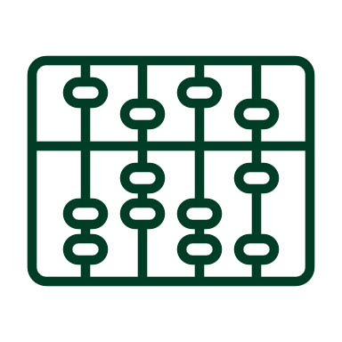**Active learning –** **lessons plan**

|  |  |
| --- | --- |
| Lesson No. | Topic |
|  | Texts: |
| 1 | Short dialogs and reading short articles |
| 2 | Reading informative texts |
|  | Vocabulary: |
| 3 | Parts of the body |
| 4 | The places that surround us |
| 5 | Israeli culture |
| 6 | Numbers |
| 7 | Question words. |
| 8 | Colors |
| 9 | Cites in Israel |
|  | Grammar: |
| 10 | Understanding the changes which are caused by gender, and how it impacts numbers |
| 11 | Verbs |
| 12 | Sentence with verbs |

* There may be changes in the syllabus depending on learning progress and effectiveness

**Final grade**

|  |  |
| --- | --- |
| Description of the learning product | Weight in the final score |
| Homework, Quizzes, Class participation | 30% of the final grade |
| Final test | 70% of the final grade |