
Date: Oct. 2026

Syllabus - Teaching Program for the Course
Elementary Hebrew Language Ulpan level 2
Janet Ben Harush
0602601

Course Type: | Lecture
Scope of credits: | 2
Year of study: | 2026-2027
Semester: | Fall
Day & Time: | Tuesday, 12:00-13:30
Reception Time: | Upon appointment
Lecturer Email: | Janet.ben-harush@biu.ac.il
Moodle Site: | https://lemida.biu.ac.il/
Course description and learning goals

Course Abstract
To improve mastery of the Hebrew language in reading, writing, comprehension, speaking, as well as deepening grammar's grasp.

Learning objectives

Knowledge
- The basis of the verb, noun, adjective and syntax.
- In practice: All Tenses.
- Syntax: All sentences’ types.
- Nouns: Numbers, noun + adjective, abbreviations, synonyms and antonyms, derivation.
Skills
- Reading: Cultivating reading ability, enriching vocabulary and preparing for level 2.
- Writing: Cultivating the expressing ability in writing with a focus on vocabulary widening, correct spelling and sentence structure.
- Comprehension and speaking: Mastery of comprehension and speaking skills; improvement in conversation management skills.

Values (if applicable)
Some of the course topics include reading passages that are processed to meet the required level. The passages are selected to be relevant and appropriate to topics in public discourse, Jewish-Zionist themes, and Israeli identity.

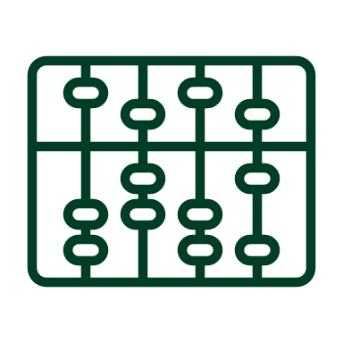Lessons plan:
Lesson No. | Topic
1 | שיעור היכרות-משמעות השם וחשיבותו
2 | חלקי הדיבר
3 | שמות עצם חריגים-ה' הידיעה
4 | סמיכות-זכר ונקבה, יחיד ורבים
5 | הכרת מערכת הפועל ושבעת הבניינים
6 | פועל שלמים-עבר והווה
7 | משפטי תכלית+צירופי שם פועל
8 | פעל ע"ו עבר והווה
9 | מספרים מונים-זכר ונקבה
10 | מספרים סודרים+ פסוקית מושא
11 | הפועל להיות, מילת היחס ל'
12 | גוף האדם, מילות היחס אצל ו"ב"
13 | השוואה ויתרון, יותר, מאשר.
14 | מילות קישור-סיבה ותוצאה
* There may be changes in the syllabus depending on learning progress and effectiveness

Final grade
Description of the learning product | Weight in the final score
Active class participation | 10%
Completing assignments during the course | 20%
Midterm exams | 20%
Final exam | 50%

Course requirements
Assignments: Submitting homework assignments and exercises, as well as responding to questions on the texts we have studied.
Attendance: 80%

 Prerequisites:
Basic reading and writing knowledge.

