
Date: Oct. 2026

Syllabus - Teaching Program for the Course
Foundation of Judaism
Dr. Chana Tannenbaum
05-454-80

Course Type: | Lecture
Scope of credits: | 1
Year of study: | 2026-2027
Semester: | Spring
Day & Time: | Thursday 10:30-11:45
Reception Time: | Upon appointment
Lecturer Email: | DrcTann@gmail.com

Course description and learning goals

Course Abstract
This introductory course explores the fundamental questions and concepts that have shaped Jewish philosophy throughout history. Students will engage with key philosophical ideas and arguments, examining topics such as existence of God, knowledge of written and oral Torah, morality, and the human condition. Through critical reading, discussion, and writing, students will develop the ability to think philosophically and apply philosophical methods to their lives.

Learning objectives
Understand Core Philosophical Concepts: Identify and explain key concepts, theories, and arguments in the history of Jewish philosophy.

Knowledge

- Learners will read and critically analyze primary Jewish philosophical texts, recognizing central arguments and evaluating their strengths and weaknesses.
- Learners will define fundamental Jewish philosophical terms (free will, divine providence)

Skills
The learners will apply logical reasoning and critical thinking skills to philosophical problems and everyday situations. They will analyze sources and evaluate the ramifications.

The learners will participate in thoughtful and respectful discussions, considering diverse perspectives and counterarguments.

Values (if applicable)
The learners will relate philosophical theories and ideas to current social, ethical, and political issues, demonstrating the relevance of Judaism to modern life.
The learners will examine and articulate their own beliefs and values in light of philosophical inquiry, fostering self-awareness and intellectual and spiritual growth.
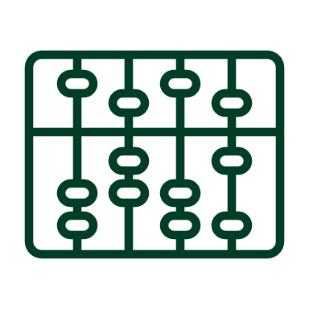Active learning – lessons plan:

You can plan an active learning process for the entire course or listfor each active learning activity lesson in the following table:

Lesson No. | Topic | Active learning | Required reading | Assessment
1 | Land of Israel | Discussions | Source sheets | Answering one thought question to be turned in.
2 | Jewish concept of Marriage | Discussions | Source sheets | Answering one thought question to be turned in.
3 | Shabbat | Discussions | Source sheets | Answering one thought question to be turned in.
4 | Prayer | Discussions | Source sheets | Answering one thought question to be turned in.
5 | Between man and his neighbor | Discussions | Source sheets | Answering one thought question to be turned in.
6 | Kashrut | Discussions | Source sheets | Answering one thought question to be turned in.
7 | Science and Torah | Discussions | Source sheets | Answering one thought question to be turned in.
8 | Messiah | Discussions | Source sheets | Answering one thought question to be turned in.
9 | World to Come | Discussions | Source sheets | Answering one thought question to be turned in.
10 | Reincarnation | Discussions | Source sheets | Answering one thought question to be turned in.
11 | Resurrection | Discussions | Source sheets | Answering one thought question to be turned in.
12 | Teshuva | Discussions | Source sheets | Answering one thought question to be turned in.
13 | Final
14
(In a course that lasts a whole year, the additional sessions should be added)
* There may be changes in the syllabus depending on learning progress and effectiveness

Final grade
Active participation in class- Answering one thought question to be turned in.25%
Project 25%
Final 50%
Description of the learning product | Weight in the final score
Answering one thought question to be turned in. | Will account for 25% of the final grade
Midterm project | 25%
Final | 50%

Course requirements

- Assignments – assigned to the student as part of the course, such as: exercises, written work, reports, presentations.
- Attendance – if there is a requirement – it must be explicitly stated and defined. Usually 80-85% attendance is required. In laboratories, workshops, etc., higher attendance may be required.

 Prerequisites
This course is designed for students with no prior background or knowledge in Jewish philosophy, aiming to provide a solid foundation for further philosophical study and to cultivate skills that are valuable across various disciplines and professions.
The only prerequisite is the desire to learn.

