
Date: September 2026

Syllabus - Teaching Program for the Course
Hebrew -Ulpan level 1
Tsila Allon| International School
06025| Hebrew -Ulpan level 1

Course Type: | class, exercise
Scope of credits: | 2
Year of study: | 2026-27
Semester: | 1st
Day & Time: | Tuesday at 12:15
Reception Time: | Tuesday at 2pm
Lecturer Email: | cila.allon@biu.ac.il
Moodle Site: | https://lemida.biu.ac.il/course/view.php?id=114719

Course description and learning goals

Course Abstract
In this course we will continue to acquire the basic vocabulary and structures of the Hebrew language with focus on speech, reading comprehension, and simple writing.

Learning objectives
This course takes the students from the mechanics of reading and writing Hebrew to active mastery Gradual Vocabulary; knowledge of the present tense verb forms and basic sentence structures; reading and enactment of dialogs relating to everyday life; and reading comprehension of short descriptive, narrative and informative texts.

Knowledge
Familiarity of the basics on the written and spoken Hebrew:
- Familiarity of the basics on the written and spoken Hebrew.
- Day to day dialogs – speaking and reading.
- Understanding the basic syntax.
- Establishing a basic vocabulary.
Skills
By the end of the semester, it is expected that students will be able to:
- Read familiar text without vowels
- Understand and produce an account of daily activities using the present tense, time of day and days of the week
- Describe people, places and actions both orally and in writing using newly acquired vocabulary and structures
- Use numbers (to count, tell time and phone numbers, street address, etc.)
- Ask and answer simple questions (where, when, who, why, how, how much)

Teaching techniques, technology use
- During the lessons the students will talk, read texts and write. PowerPoint presentations and digital practice will also be used.

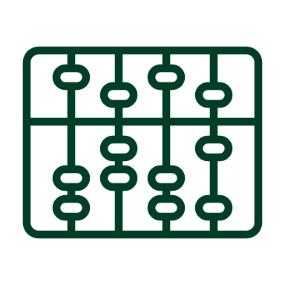Active learning – lessons plan

Lesson No. | Topic
1 | Texts:
2 | Short dialogs and reading short articles.
3 | Vocabulary:
4 | Personal Pronouns
5 | Question words.
6 | Names of places.
7 | Numbers
8 | How to tell the time
9 | Colors
10 | Days of the week
11 | Grammar:
12 | Familiarity with nouns and adjectives.
13 | Prepositions
14 | Review
* There may be changes in the syllabus depending on learning progress and effectiveness

Final grade
Description of the learning product | Weight in the final score
Homework, Quizzes, Class participation | 30% of the final grade
Final test | 70% of the final grade

 Prerequisites
The students will be placed in the course according to the results in the placement test
Course number | Course name
 | Hebrew -Ulpan level 1

