
Date: September 2026

Syllabus - Teaching Program for the Course
Hebrew -Ulpan level 1
Tsila Allon| International School
06035| Hebrew -Ulpan level 1
Course Type: | class, exercise
Scope of credits: | 2
Year of study: | 2026-27
Semester: | 2nd
Day & Time: | Tuesday at 12
Reception Time: | Tuesday at 2pm
Lecturer Email: | cila.allon@biu.ac.il
Moodle Site: | https://lemida.biu.ac.il/course/view.php?id=118122

Course description and learning goals

Course Abstract
The course is intended for those who have completed the first Semester of Ulpan 1. In this course we will continue to develop the basic vocabulary and structures of the Hebrew language with focus on speech, reading comprehension, and simple writing.
Learning objectives
In this course we will continue to improve the students reading and writing Hebrew and their active Vocabulary; knowledge of the present tense verb forms and basic sentence structures; We will continue to work on reading and enactment of dialogs relating to everyday life; and reading comprehension of short descriptive, narrative and informative texts.

Knowledge
Familiarity of the basics on the written and spoken Hebrew:
- Day to day dialogs – speaking and reading
- Understanding the basic syntax
- Establishing a basic vocabulary
- The Hebrew verb system
- Sentence with verbs
Skills
By the end of the semester, it is expected that students will be able to:
- Read familiar text without vowels
- Understand and produce an account of daily activities using the present tense, time of day and days of the week
- Describe people, places and actions both orally and in writing using newly acquired vocabulary and structures
- Use numbers (to count, tell time and phone numbers, street address, etc.)
- Ask and answer questions (where, when, who, why, how, how much)

Teaching techniques, technology use
- During the lessons the students will talk, read texts and write. PowerPoint presentations and digital practice will also be used.
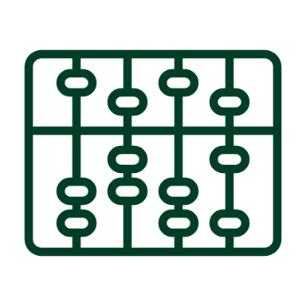Active learning – lessons plan

Lesson No. | Topic
 | Texts:
1 | Short dialogs and reading short articles
2 | Reading informative texts
 | Vocabulary:
3 | Parts of the body
4 | The places that surround us
5 | Israeli culture
6 | Numbers
7 | Question words.
8 | Colors
9 | Cites in Israel
 | Grammar:
10 | Understanding the changes which are caused by gender, and how it impacts numbers
11 | Verbs
12 | Sentence with verbs
* There may be changes in the syllabus depending on learning progress and effectiveness

Final grade
Description of the learning product | Weight in the final score
Homework, Quizzes, Class participation | 30% of the final grade
Final test | 70% of the final grade

 Prerequisites
The students will be placed in the course according to the results in the placement test
Course number | Course name
 | Hebrew -Ulpan level 1

